

**Google Cloud Platform (GCP) Backup**

**Plugin Configuration Guide**

Contents

Configuration Checklist 2

Supported Collection Types 2

Data Sources 2

Requirements 2

Firewall Ports 2

GCP API Credentials 2

Setup 3

Server Properties 3

Field Definitions 3

Troubleshooting 4

Test Connection 4

Reporting Notes 4

Technical Support 4

# Configuration Checklist

Here is a quick checklist for deployment of GCP. Detailed instructions are in later sections:

Ensure a *Service Account Key* is available when configuring an GCP Backup server:

# Supported Collection Types

The plugin supports the following collection types from GCP Backup:

|  |  |  |
| --- | --- | --- |
| **Collection Type** | **Supported** | **Description** |
| Backup | ✓ | Collects transactional details about backups. Example metrics include, start times, durations, bytes, and errors, etc. |
| Storage | ✓ | Collects point-in-time inventory information. Example metrics include, total recoverable gigabytes (storage), media volume count, media volume status, etc. |
| Policy |  | Collects and stores information on policy attributes, schedules, storage destinations, and backup objects. |
| In Progress |  | Collects basic information on backups that are running or have completed since the previous full Backup jobs data collection. These updates are included in the Backup updates, but are lightweight and can be scheduled more often than backup updates if needed. |

Bocada currently reports on the following backups:

* Virtual Machines
* Spanner backups

# Data Sources

The plugin relies on the following GCP data sources:

* Google API

The scope of data collected from GCP is limited to what is available to the API.

See also: <https://cloud.google.com/docs/authentication/production> for GCP API credential reference.

# Requirements

This section lists requirements that must be met prior to collecting data with the Bocada plugin for GCP.

### Firewall Ports

|  |  |  |
| --- | --- | --- |
| **Service** | **Default Port** | **Note** |
| HTTPS | 443 | Outbound from DCS to Google API |

# GCP API Credentials

Bocada Collections rely on the use of a service account with a viewer role. Create a Service Account and a JSON Key by following the “Creating a service account” section of the following link. <https://cloud.google.com/docs/authentication/production> When Selecting a Role, choose the Viewer. Once the service account key is created, copy the JSON Key file to the DCS. This file will be used during setup.

Note that Bocada GCP collections will be based on projects, which are added to the service account, which will be used in backup server properties.

**You also can use the step-by-step guide below to create a Cross Project service account for Bocada collections:**

1. Login to <https://console.cloud.google.com> and select the first project you need to collect in Bocada:

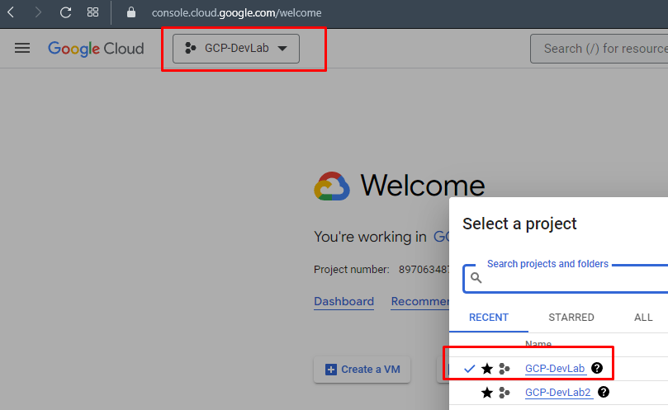

1. Go to the “Create service account” page: <https://console.cloud.google.com/iam-admin/serviceaccounts/create>
2. Fill in the service account details as per your needs. Then press CREATE AND CONTINUE:

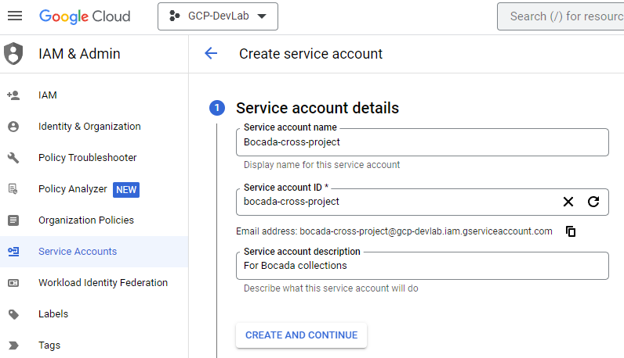

# Setup

### Server Properties

Backup Server Properties determine how the plugin will interface with the GCP and are managed through the Backup Servers view.

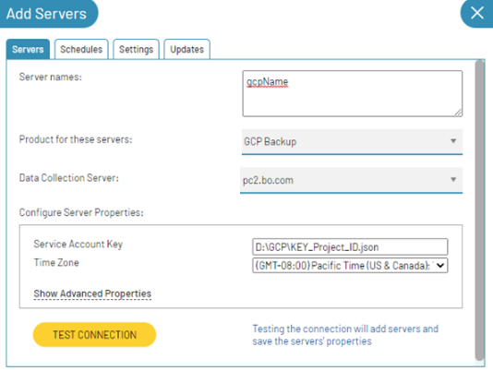

### Field Definitions

#### Server name

Enter a name for the GCP that you wish to see within Bocada. Use descriptive name within Bocada to associate GCP API Service Account key.

#### Service Account Key

Enter the service account key file full path OR a full folder path which includes all service account key files you are interested in projects. Examples: D:\GCPkeyFilesInJSON

#### Time Zone

Select the time zone where GCP server resides. This setting ensures times are displayed consistently in environments that span multiple time zones.

# Troubleshooting

## Test Connection

Test Connection is using server properties to get limited backup activities, check the message for the reason.

The message ‘test connection successful’ indicates events are collected successfully, otherwise the message should tell the user the specific error.

If the message is ‘Test connection failed’, this could be due to incorrect server settings API configuration. Try running data collection updates to see if any backup being collected.

If no data is collected, further diagnostic may be required, using postman for example.

# Reporting Notes

There are currently no dedicated reporting notes for GCP backup.

# Technical Support

For technical support, or for a copy of our standard support agreement, please contact us.

**E-mail:** [support@bocada.com](mailto:support@bocada.com)

**Support Portal:** <https://bocada-support.force.com>

**Phone:** +1-425-898-2400